**Yoodlize Documentation**

**Test Plan**

**Overview:**

Test functionality of Yoodlize web application.

Link: <https://alpha.yoodlize.com/>

**Test Criteria:**

Locate where to sign-up and determine functionality.

Ensure that the sign-up and log-in functionality works.

Make sure that the search feature works.

Test what happens when a city is enter in the city field.

Test the filter functionality for the advanced search.

Review the How it Works links, page and video.

Check the functionality of the map in the search feature.

**Entry Criteria:**

The documented test criteria

Access the website

Device for testing: Desktop and laptop

**Exit Criteria:**

All tests have passed

**Other details:**

Environment

* Chrome browser: **Version 96.0.4664.55 (Official Build) (x86_64)**

**Test Case**

**Description:**

This test will determine the functionality of the search feature, specifically when searching on Rubik’s Cube.

**Steps:**

1. Navigate to the Yoodlize (via t <https://alpha.yoodlize.com>).
2. Locate the search for an item field.
3. Enter Rubik’s Cube in the search field and click on the search icon.
4. Identify what the search results returned.
5. Continue these steps for testing as needed and document/report any findings.

**Post Condition:**

* You should now be on an item screen for a Rubik’s Cube.

Test notes/results:

* Typed Rubik’s Cube in the search field and clicked the search icon. The following was returned:

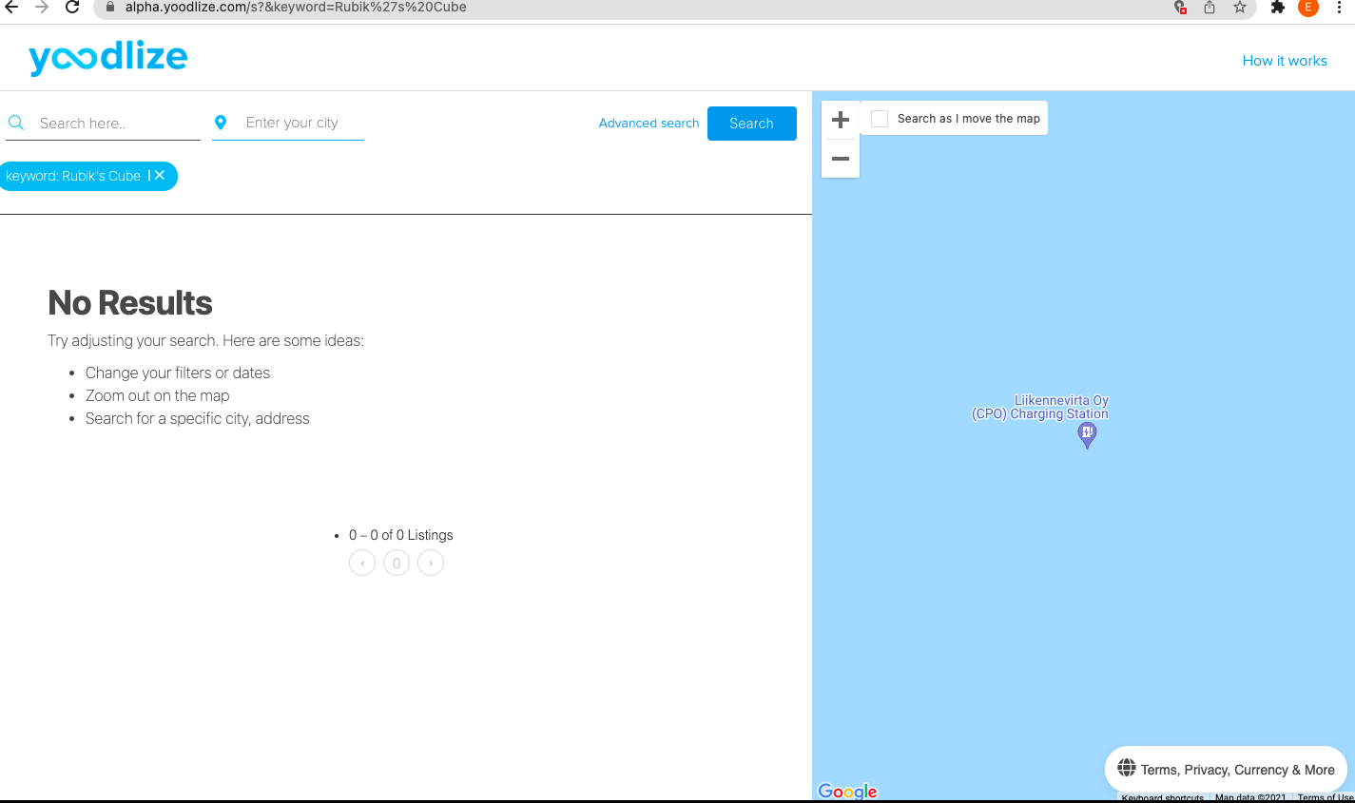

* Copied Rubik’s Cube in the search field and clicked the search icon. The following was returned:

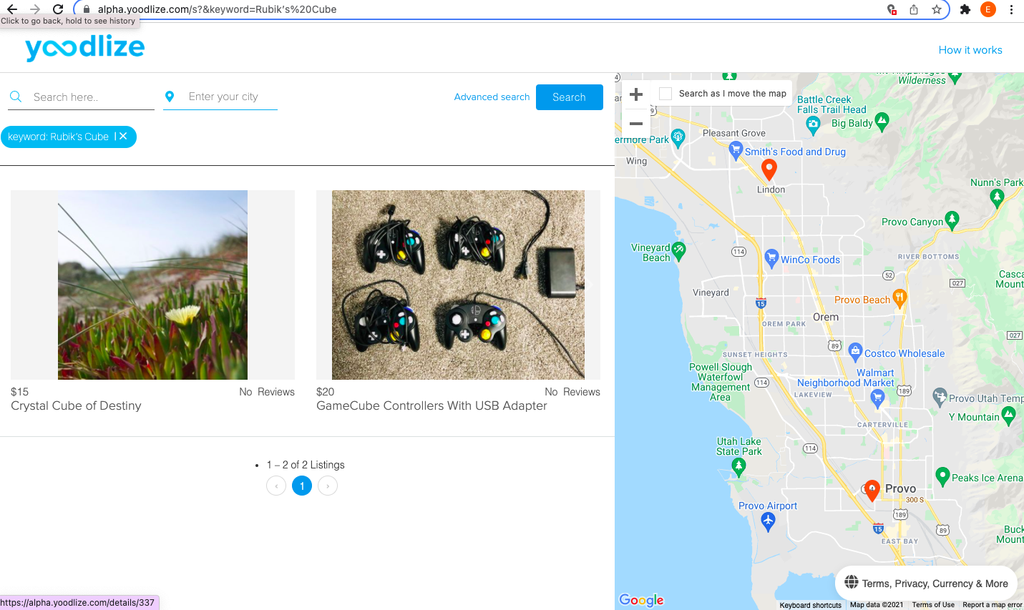

* + The results did not produce findings or a screen for a Rubik’s cube.
  + The behavior of the search seems to be searching on the word “cube” and not the full search criteria.
* Results of selecting the first item:

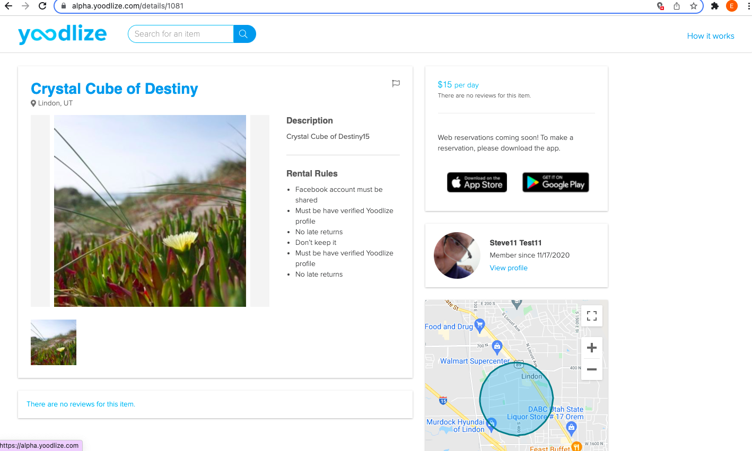

* + If the user is not logged in, there is no further action that can be taken.
* Other items searched, the advanced search option: **Outdoor Gear**
  + Steps taken:

1. Navigated to Advanced search by clicking on the home page search icon, without entering a search criteria.
2. A list of random list of un-searched items returned. (See below attachment labeled: Attachment 5.)
3. Clicked on the Advance search link.
4. The category grouping, Availability & Rating, and Price, sections displayed. (See below attachment labeled: Attachment 6.)
5. Checked the “Outdoor Gear” checkbox, selected pick-up (entered pick-up and drop-off dates), entered price (Min and Max).
6. There is no clear option to move forward once the Advance search criteria is entered. (See below attachment labeled: Attachment 6.)
   1. This appears to be the behavior when the user in not logged-in.
7. Considering that there was no clear next step, selected the Search button. Search results only changed by adding the advance search filters at the top of the list of random unsearched items. (See below attachment labeled: Attachment 7.)
8. Selected the back arrow from the existing advance search and another random list of items unrelated to the search were listed. (See below attachment labeled: Attachment 8.)

**Referenced Attachments:**

Attachment 5:

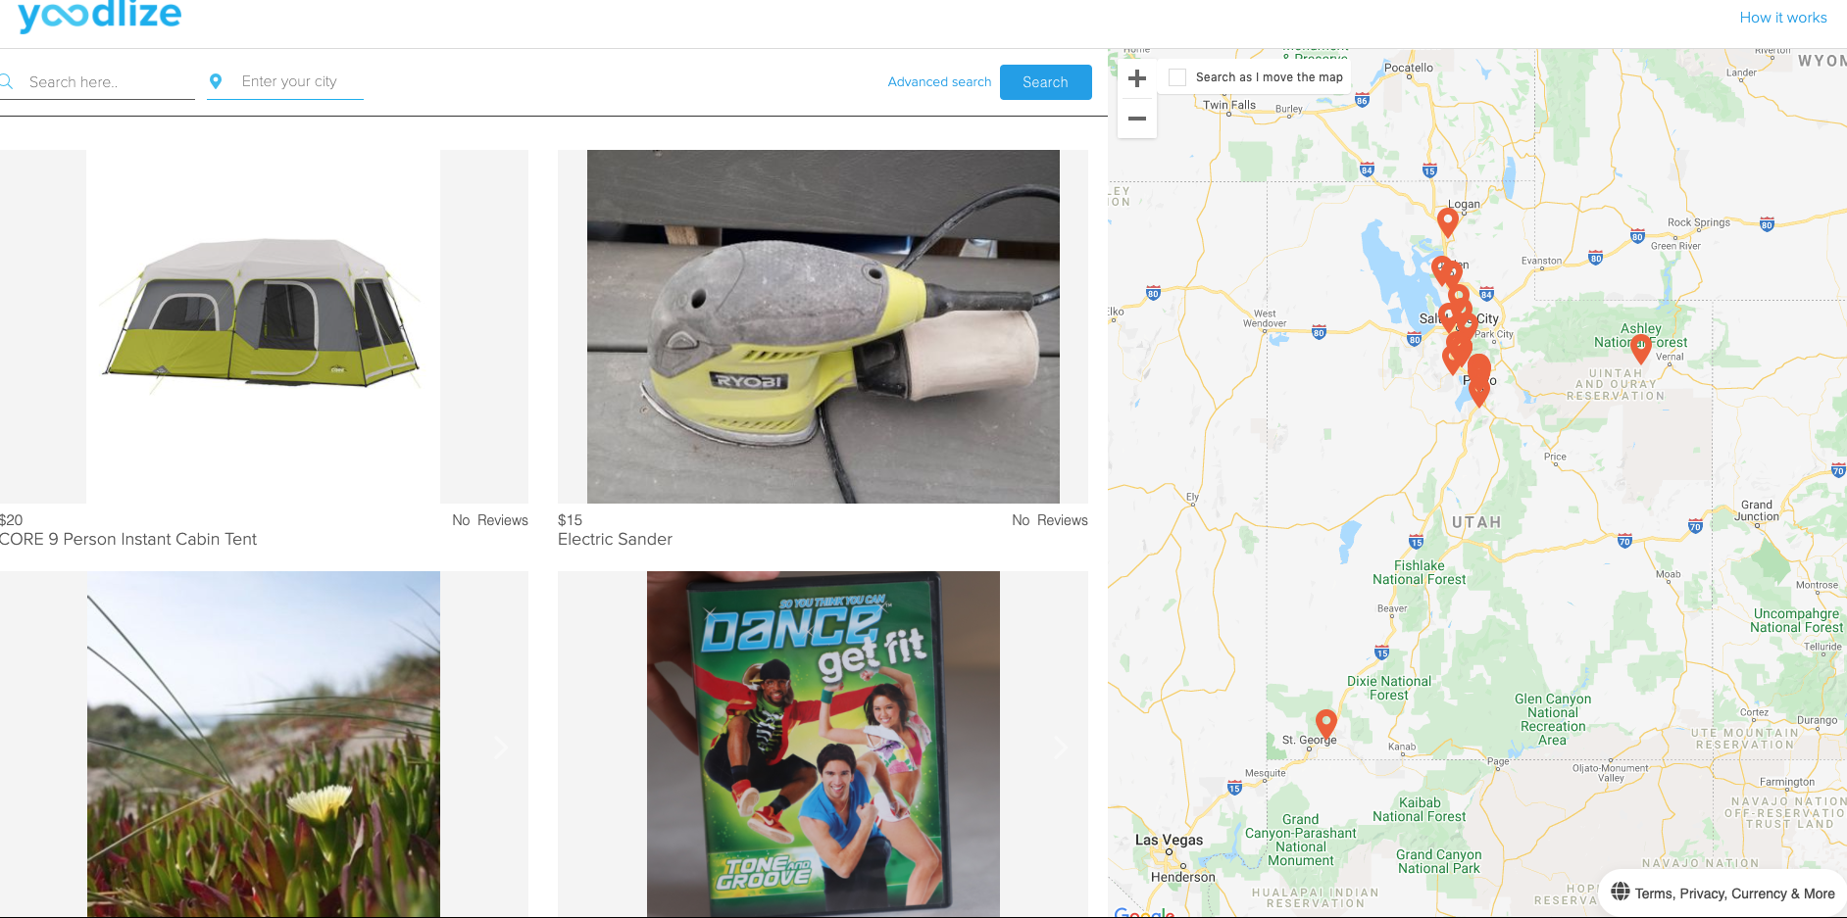

Attachment 6:

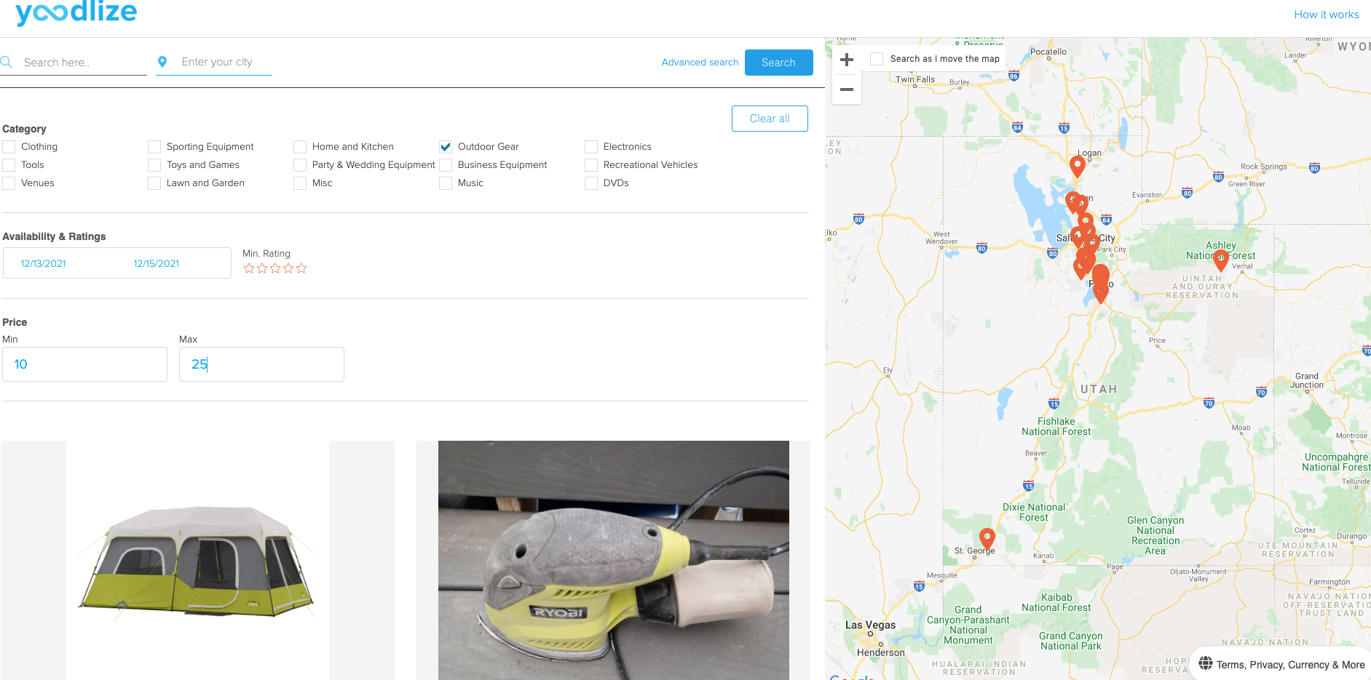

Attachment 7:

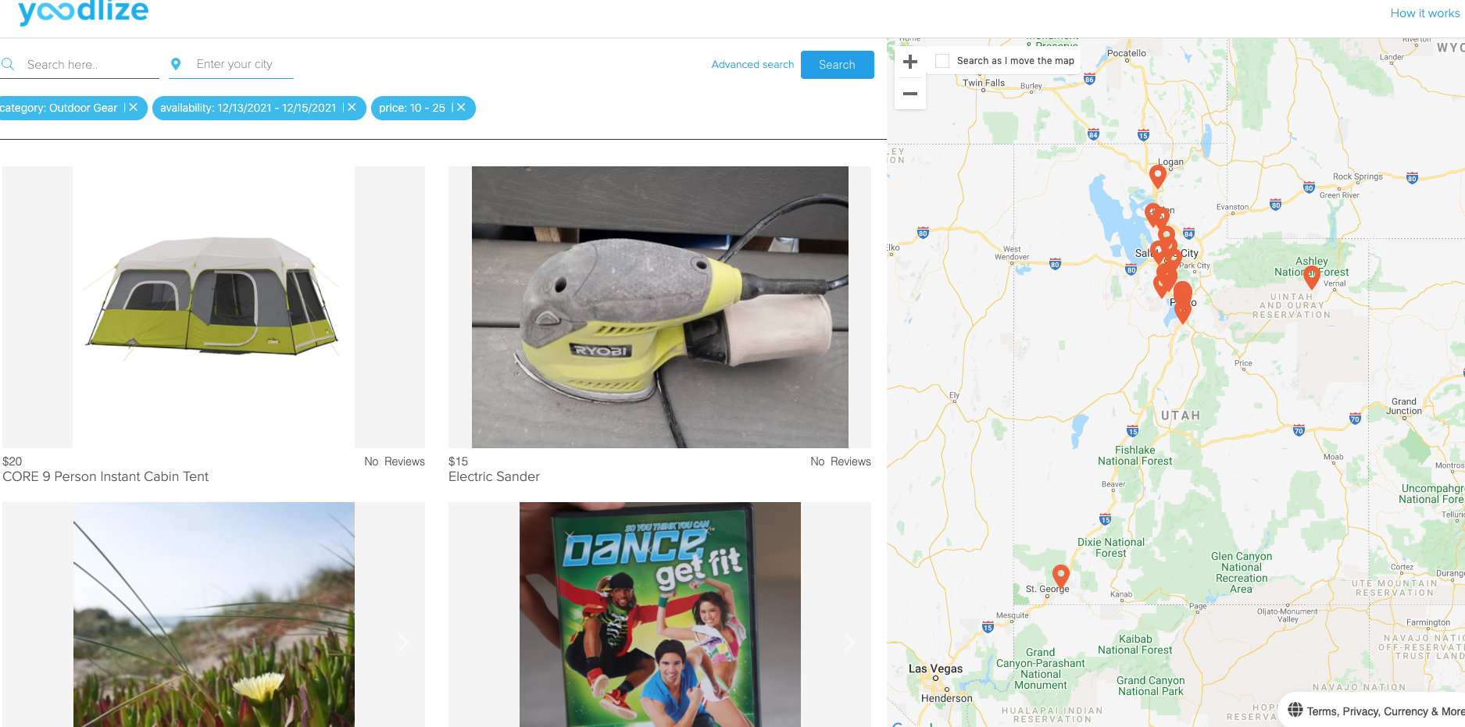

Attachment 8

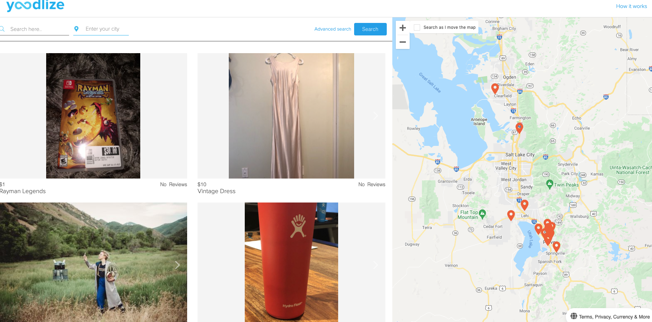

**Increasing Confidence**

Know issues:

* Locating how to sign-up is not intuitive, due to the placement of the Profile link (located at the bottom of the page) and the labeling of the sign-up being Profile and not Sign-up.
* Searching for an item(s) does not necessary return the intended item(s). Items that may return may be totally unrelated to search criteria.
* Rentals are limited to Utah. Considering that users are allowed to enter cities outside of the state of Utah, this may be confusing to an end-user.

Positive Observations:

* The initial landing page seems welcoming and speaks to the broad spectrum of potential items that can be rented.
* Denoting of the possible rental cost for items supports economical spending.
* The platform allows for owners to earn money by renting their personal items.

Report:

The findings demonstrate a potential poor end-user experience. If a user has never visited the website, they may find it difficult to navigate. There should be a notice on the landing page that states that rentals are limited to the state of Utah. When a user that has not signed-up wants to navigate the website, they may experience limitation on seeing the potential items to rent and the rental process, which does not encourage a new site visitor to sig-up.

If a user wants to sign-up, locating where to sign-up is not easy to find on the page. The new user/visitor has to scroll to the bottom of the page to locate “Profile”, which is not a clear indication of sign-up for the website. The sign-up location needs to be improved. Lastly, new users/visitors when starting the sign-up process may not feel comfortable with providing their phone number and potentially uploading a photo of their government ID.